®
Tower 42
25 Old Broad Street
London EC2N 1HQ
United Kingdom
t + 44 (0) 20 7382 1770
f + 44 (0) 20 7382 1771
www.c-ebs.org

Dear members and observers,
Invitation to the 6th European Banking Supervisors XBRL Workshop

CEBS finalized the Guidelines on Financial Reporting (FINREP) and on Common Reporting (COREP) at the beginning of this year. IT implementations of these guidelines are a matter of national discretion. In addition CEBS stated that it considers XBRL as a helpful tool in constructing a standardised European reporting system. As a consequence CEBS promoted the development of XBRL taxonomies for COREP and FINREP, which would be made available without cost to national authorities and supervised credit institutions.

A XBRL team, consisting of supervisory authorities and external parties, has been working on these taxonomies since 2004. After the integration of all reporting related topics within the recently created Expert Group on Financial Information (EGFI), it has been decided to set up within the EGFI-structure a Network which will be in charge of the more technical XBRL issues, leaving the policy aspects for the EGFI Subgroup on Reporting and the EGFI itself. This network will be based on the current structure of the XBRL team, and it will be coordinated by Ignacio Boixo, former project manager of the XBRL team.

In order to update supervisory authorities on the newest developments with respect to XBRL and to share experiences in the implementation of the XBRL projects at national level, the EGFI XBRL network in collaboration with XBRL International, is pleased to announce its intention to continue holding the European Banking Supervisors XBRL Workshops. The next one, the 6th workshop will be held in Madrid at Bank of Spain premises on October 4-5th. The workshop will mainly focus on practical issues, and it will also be opened to the participation of software vendors and representatives of banking associations. The audience will be limited to 60 attendances, but priority will be given to the representatives of European supervisory authorities.

Should a member of your authority want to attend this workshop, please send the attached registration form by september 29th cob at the latest. Additional info or details may be provided by Ignacio Boixo (+34 91 338 64 52; boixo@bde.es) or Jacobo Varela (+44 207 382 1782; jacobo.varela@c-ebs.org).

Thank you very much in advance for your cooperation.

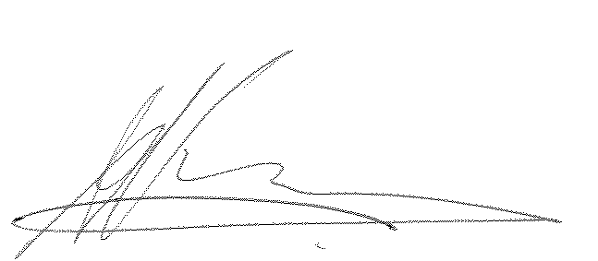
Yours sincerely

Arnoud Vossen
Chairman of Expert Group on Financial Information

